1. 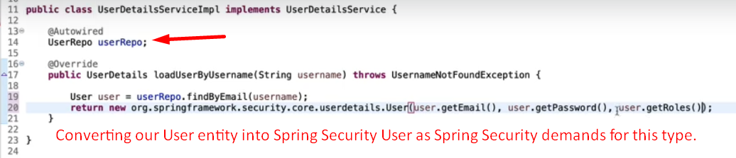
2. This is the final implementation.  
   